Retrieval Augmented Generation | What is RAG
https://www.youtube.com/watch?v=X0btK9X0Xnk&list=PLKnIA16_RmvaTbihpo4MtzVm4XOQa0ER0&index=16
What RAG is?
Why it matters?
How it works step by step?
Introduction
- The video is part of a two-part series:
  - This video: conceptual and theoretical background of RAG.
  - Next video: practical implementation of a RAG-based system using LangChain.
- This video focuses on in-depth explanation, historical context, problems RAG solves, and previous systems used before RAG.

Recap of Previous Videos
- Previous videos covered key components of RAG:
  - Document Loaders: Load data from any source.
  - Text Splitters: Split large text into smaller chunks.
  - Vector Stores: Convert text into embeddings and store them.
  - Retrievers: Perform semantic search on stored embeddings.
- With this foundation, the discussion moves to understanding RAG itself.

Roadmap
- The video follows a Why → What → How structure:
  - Why RAG is needed.
  - What RAG exactly is.
  - How RAG-based systems function.

Why RAG is Needed
- Introduction to LLMs (Large Language Models):
  - LLMs are transformer-based neural networks with millions or billions of parameters and the parameters store the learning
  - Pre-training: LLMs are trained on huge datasets (internet-scale) to acquire general knowledge.
  - Knowledge is stored in parameters (weights and biases), called parametric knowledge.
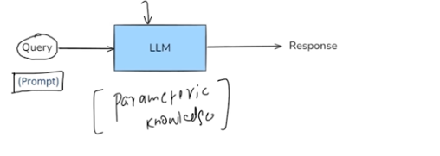
  - Larger models can store more knowledge.
- How users access LLM knowledge:
  - Users send prompts to the LLM.
  - LLM generates answers based on parametric knowledge.
  - Works well in most situations.

Limitations of LLMs
Three scenarios were prompting alone fails:
- Private Data:
  - LLM cannot answer questions about private data (e.g., internal course videos) because it was never exposed to that data.
- Recent Data / Current Affairs:
  - LLMs have a knowledge cutoff date.
  - Open-source models cannot answer questions about events after the cutoff.
  - ChatGPT works differently as it may have internet access.
- Hallucination:
  - LLMs may generate factually incorrect answers confidently.
  - Example: claiming “Einstein played football in Germany” — completely made-up.
  - Hallucinations occur due to the probabilistic nature of LLMs.

Solving Limitations with Fine-Tuning
- Fine-tuning helps LLMs:
  - Answer questions on private data.
  - Handle domain-specific or recent data.
  - Reduce hallucinations.
- Concept of Fine-Tuning:
  - Start with a pre-trained LLM.
  - Train it on a smaller, domain-specific dataset.
  - Example: training on medical data so the LLM can answer medical questions.
- Analogy:
  - A student completes engineering education (pre-training), then undergoes company-specific training (fine-tuning) for specific tasks.
- Fine-tuning Techniques:
  - Supervised Fine-Tuning (SFT):
    - Use a labeled dataset of prompts and desired outputs.
    - Model learns to map prompts to correct answers.
  - Continued Pre-Training:
    - Unsupervised approach using domain-specific datasets without labels.
  - RLHF (Reinforcement Learning with Human Feedback):
    - Combines reinforcement learning and human feedback for real-world behavior.
  - Other techniques: LoRA, QLoRA — parameter-efficient fine-tuning.

Supervised Fine-Tuning Process
Four-step process:
- Data Collection:
  - Collect domain-specific dataset (prompts and desired outputs).
- Select Fine-Tuning Method:
  - Choose full parameter fine-tuning or parameter-efficient methods like LoRA/QLoRA.
- Training:
  - Train for a few epochs (full retraining is computationally expensive).
  - Full fine-tuning retrains all weights; LoRA freezes base weights and trains only additional weights.
- Evaluation:
  - Assess quality using:
    - Exact match with desired outputs.
    - Factual accuracy.
    - Hallucination reduction.

How Fine-Tuning Solves LLM Limitations
- Private Data Queries:
  - Fine-tuning on private data allows LLM to answer domain-specific queries.
- Recent Data Queries:
  - Fine-tuning on updated datasets makes the model aware of recent content.
  - Requires repeated fine-tuning if data updates frequently.
- Hallucination:
  - Train with examples to teach the model not to fabricate answers.
  - Example: For tricky prompts, instruct the model: "If unsure, answer 'I don't know'."
  - Reduces hallucinations effectively.

Limitations of Fine-Tuning
- Fine-tuning cannot be applied everywhere logically. There are several major problems with fine-tuning:
- Computational Cost:
  - Even when training on a small dataset, fine-tuning a large model is computationally expensive.
  - Significant costs are incurred due to required hardware and cloud resources.
- Technical Expertise Required:
  - Fine-tuning large models requires strong AI/ML expertise.
  - You need skilled engineers or data scientists; not everyone can perform fine-tuning.
- Frequent Updates Are Expensive:
  - If the underlying data updates frequently (e.g., course catalogs, website content), you need to re-fine-tune every time.
  - Removing outdated data also requires additional fine-tuning.
  - Overall, fine-tuning is not suitable for scenarios with rapidly changing data.
Conclusion: Fine-tuning is not practical for every use case, especially where data changes often or expertise is limited.

In-Context Learning (ICL)
- A solution to fine-tuning limitations is in-context learning.
- Definition:
In-context learning is a core capability of large language models (LLMs) like GPT-3 or LLaMA, where the model learns to solve a task purely by seeing examples in the prompt without updating its weights.
How It Works
- LLM Parametric Knowledge:
  - LLMs have pre-trained knowledge stored in parameters.
  - Normally, prompts query this knowledge to generate answers.
- Learning from Examples:
  - By providing examples directly in the prompt, LLMs can learn to perform a task.
  - Example: Sentiment analysis
    - Example 1: "I love this phone. → Positive"
    - Example 2: "This app crashes a lot. → Negative"
    - New input: "I hate the battery life" → Model predicts Negative.
- Applications:
  - Named Entity Recognition (NER), math problem solving, domain-specific tasks.
- Few-Shot Prompting:
  - Providing a few labeled examples in the prompt is also called few-shot prompting.
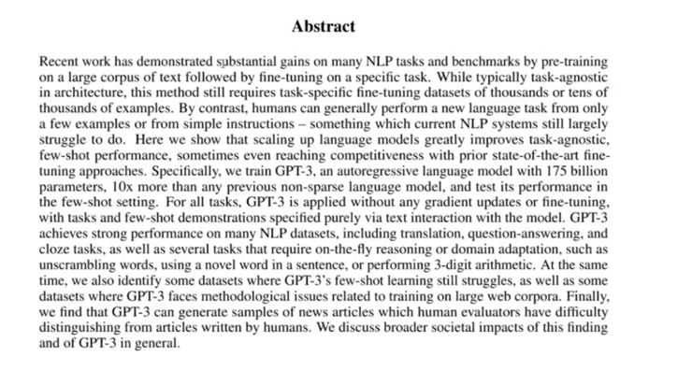

Emergent Property of LLMs
- In-context learning is an emergent property:
  - Emergent properties are behaviors that appear naturally when a system reaches a certain scale and complexity.
  - LLMs like GPT-3 (175B parameters) automatically exhibit in-context learning without explicit programming.
  - Smaller models (GPT-1, GPT-2) did not reliably show this property.
- Historical Note:
  - Landmark paper: “Language Models are Few-Shot Learners” introduced and demonstrated in-context learning.
  - Humans can solve tasks from just a few examples; similarly, LLMs can now do the same.

Enhancing In-Context Learning → RAG
- Problem with plain in-context learning:
  - Examples must be embedded in the prompt, which has context size limitations.
- Improvement: Using full context instead of just examples
  - Provide the entire relevant context (transcripts, documents) instead of a few examples.
  - Example: A 2-hour lecture on Linear Regression:
    - Student asks a question about Gradient Descent.
    - Instead of sending the whole 2-hour transcript, extract only the segments covering Gradient Descent.
    - Send these segments along with the query.
- How it works:
  - Inject relevant context into the prompt.
  - LLM combines parametric knowledge + injected context.
  - LLM generates an accurate response without hallucinations.
- This approach is called RAG (Retrieval-Augmented Generation):
  - Makes an LLM smarter by providing extra information at query time.
  - Extra information = extracted context relevant to the user query.

RAG System Overview
- High-level Concept:
RAG combines two main ideas:
  - Information Retrieval (IR): Find relevant content from external knowledge bases.
  - Text Generation: Generate responses using LLMs.
- Four Steps in RAG:
  - Indexing:
    - Build an external knowledge base.
    - This knowledge base will provide context when answering queries.
  - Retrieval:
    - Analyze the user query.
    - Search the knowledge base for relevant segments (chunks) related to the query.
    - Example: Extract transcript segments specifically covering Gradient Descent instead of the full lecture.
  - Augmentation:
    - Combine retrieved context + user query to form the prompt.
    - This ensures the LLM has sufficient information to answer accurately.
  - Generation:
    - LLM generates a response using both its parametric knowledge and the retrieved context.
- Example of RAG Prompt:
- You are a helpful assistant. Answer the question ONLY using the provided context.
- Context: [Gradient Descent transcript segment from 5-25 mins]
- Question: How does Gradient Descent work?
- If the context is insufficient, just say "I don't know."
- Outcome:
  - The LLM leverages both pre-trained knowledge and dynamic context to answer questions accurately.
  - Solves three main fine-tuning problems:
    - Avoids frequent expensive fine-tuning.
    - No need for expert intervention for every update.
    - Can handle frequently changing information efficiently.

RAG-Based System Documentation
This script explains how a RAG (Retrieval-Augmented Generation) system works, detailing its four main stages: Indexing, Retrieval, Argumentation, and Generation. It also highlights how RAG solves common LLM problems such as hallucination, outdated knowledge, and private data access.

1. Overview of RAG Pipeline
A RAG system works in four broad stages:
- Indexing – Preparing the external knowledge base for efficient search.
- Retrieval – Fetching the most relevant pieces of information from the knowledge base based on the user query.
- Argumentation – Creating a prompt for the LLM by combining the user query with the retrieved context.
- Generation – The LLM generates a response using its internal knowledge and the provided context.
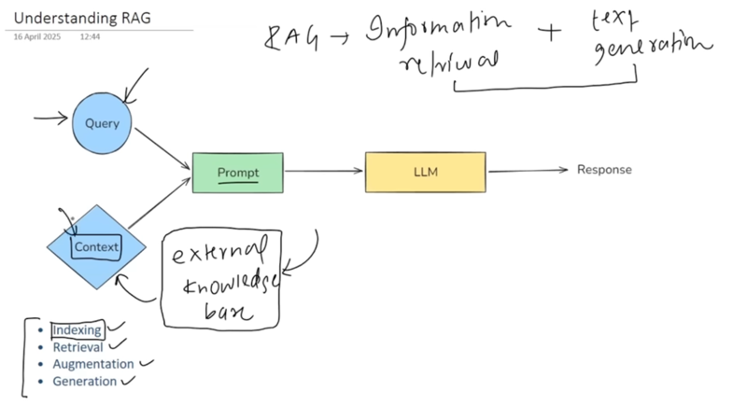

2. Stage 1: Indexing
Goal: Prepare an external knowledge base so that it can be efficiently searched when a query arrives.
Steps of Indexing:
Step 1: Document Ingestion
- Load your source knowledge into memory.
- Examples:
  - Video transcripts from your server
  - Company documents from Google Drive or AWS S3
- Tools like LangChain provide prebuilt document loaders for PDFs, YouTube, web pages, etc.
- Outcome: The document is loaded as a string for further processing.
- 

Step 2: Text Chunking
- Split large documents into smaller, semantically meaningful chunks.
- Reason:
  - LLMs have context length limitations—cannot process large documents in one prompt.
  - Semantic search quality drops on very large documents.
- Ensure chunks are topic-coherent, e.g., each chunk covers a single topic.
- LangChain provides multiple text splitters:
  - Recursive character splitter
  - Semantic chunkers
  - HTML-based or Markdown-based splitters
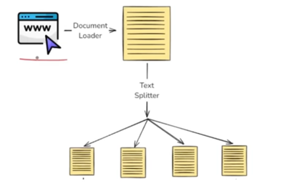

Step 3: Embedding Generation
- Convert each text chunk into dense vectors (embeddings) using a deep learning model.
- Purpose: Semantic search is performed on these vectors.
- Models can be:
  - OpenAI embeddings
  - Sentence Transformers
  - Other popular embedding models
- Outcome: Each chunk is now represented as a dense vector capturing its meaning.
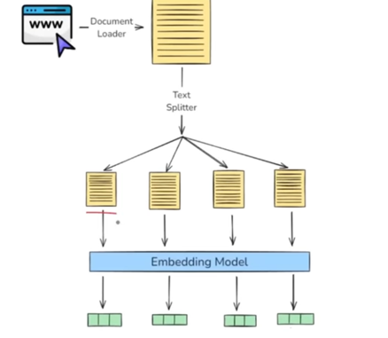

Step 4: Storing Embeddings in a Vector Database
- Save the embeddings along with original text and metadata in a vector store.
- Options:
  - Local: FAISS, Chroma
  - Cloud: Pinecone, Milvus, Weaviate, Quadrant
- Outcome: External knowledge base is ready for semantic search.
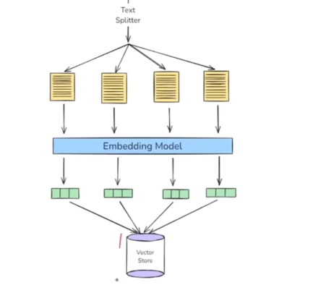

3. Stage 2: Retrieval
Goal: Find the most relevant information from the indexed knowledge base for a given query.
Steps of Retrieval:
- Query Embedding Generation
  - Convert the user query into a vector using the same embedding model used for text chunks.
- Semantic Search
  - Compare the query vector with all vectors in the vector store.
  - Find closest vectors (most semantically similar chunks).
  - Techniques:
    - Simple cosine similarity
    - Advanced approaches like Maximum Marginal Relevance (MMR) or contextual re-ranking
- Ranking and Fetching
  - Rank relevant chunks by similarity.
  - Fetch top chunks to be used as context.
  - These chunks are later combined with the query in the next stage.
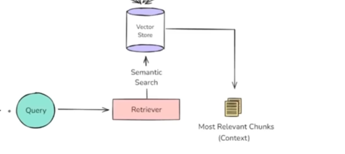

4. Stage 3: Argumentation (Prompt Creation)
Goal: Prepare a prompt for the LLM that combines the user query with the retrieved context.
Steps:
- Take the retrieved chunks (context) and the user query.
- Create a structured prompt such as:
- You are a helpful assistant.
- Answer the question using ONLY the provided context.
- If the context is insufficient, respond "I don't know."

- Context: <retrieved chunks>
- Question: <user query>
- Outcome: LLM now has relevant, grounded information to generate accurate answers.
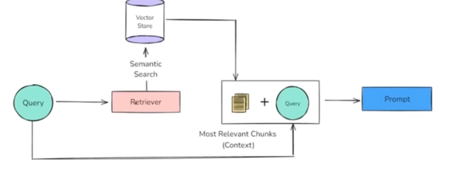

5. Stage 4: Generation
Goal: Generate the final response using LLM.
Steps:
- Send the prompt (query + context) to the LLM.
- The LLM combines:
  - Its parametric knowledge
  - The provided context
- LLM generates the answer.
- Outcome: The response is grounded in the provided context and relevant to the user query.
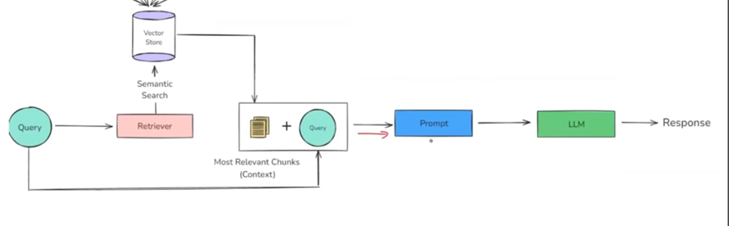
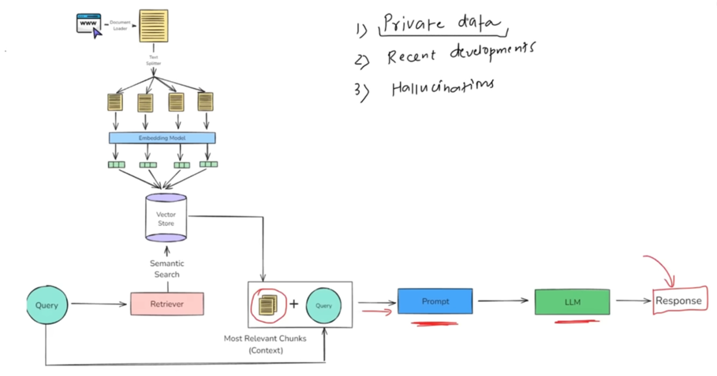

6. How RAG Solves Common LLM Problems
Problem | How RAG Solves It
Private Data Access | Context is derived from your external knowledge base, e.g., company documents. Answers come only from your data.
Outdated Knowledge | Add new articles, documents, or data to the knowledge base. No need to retrain the model.
Hallucination | Provide exact context to the model. Explicit instructions: "Answer only from provided context." Reduces hallucinations.

7. Advantages of RAG over Fine-Tuning
- Cost-Effective: No need to retrain or fine-tune models on new data.
- Faster Updates: Simply add new documents to the vector store.
- Simplicity: No labeled datasets required.
- Reduced Complexity: No full model training is required.
- Grounded Responses: LLM answers are based on verified external context.

8. Summary of Workflowf
- Indexing
  - Load documents → Split into chunks → Generate embeddings → Store in vector database
- Retrieval
  - Convert query to embedding → Search vector store → Rank top chunks → Fetch context
- Argumentation
  - Combine query + context → Create prompt
- Generation
  - Send prompt to LLM → Generate response → Deliver answer

Conclusion:
RAG-based systems provide a robust and flexible alternative to traditional fine-tuning approaches. They allow LLMs to answer queries from private, up-to-date, and verified data with minimal cost and complexity, while reducing hallucinations.

